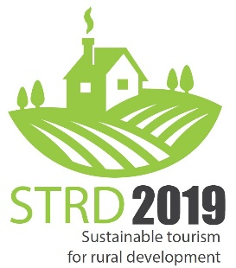
PROGRAMME
Vers. 190131

Thursday, 14th-February
Joint evening event with the Seminar on Experiential Tourism during the same day.
Public roundtable, declaration, etc. together with representatives from the Experiential Tourism seminar - tbd (in relaxed format)

Friday, 15th-February
Time | Programme item
9:00 | Inauguration and welcome notes
9:10 | Challenges for rural areas: digitalization, demography, accessibility  - Digitalization – Ms. Marie-Noël Neven, Smart Eco-Villages  - Active Ageing – Mr. Silvio Bonfiglio, AGE Platform and Ancescao  - Accessibility of tourism services – Mr. Ivor Ambrose, Managing Director ENAT  Practical case: EGWA – European Greenways – Mr. Roberto Rovelli / Mr Gianpaolo Cirone
10:40 | Coffee break
11:00 | Opportunities for rural areas through tourism: landscape, authenticity, nature, new markets for local produce  - Nature Parks – BirdLife International, Ms Federica Luoni  - Landscape association – Mr. Patrick Worms  - Distribution of eco and local products – Mr. Alberto Palacios, Farmidable  Practical case: ProLoco UNPLI – N.N.
12:30 | Lunch
13:30 | Ways forward: Smart territories, new CAP, local and cross-sectorial cooperation  - ELARD – Ms Kirsten Birke-Lund  - DG Agriculture – Ms. Karolina Jasinska  - Rural Entrepreneurship hubs – O’Gonnelloe/Ireland, Mr. Peadar Casey  Practical case: Ms. Federica Burini – University of Bergamo
15:00 | Coffee break / Opening of the Fair
15:30 | High-level Roundtable  - Ministry of Agriculture and Tourism (IT) – tbc  - Ms Mercedes Bresso - European Parliament  - N.N. Rep of COPA-Cogeca  - Mr. Gérard Peltre - MER  - Mr. Tim Fairhurst – ETOA and NET (European Tourism Industry umbrella)
17:00 | Winners Marketplace - Conclusions
17:30 | Closure

Simultaneous interpretation to and from Italian, English, and French

